North Ayrshire
Domestic Abuse Policy
All Tenures


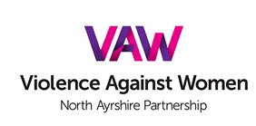

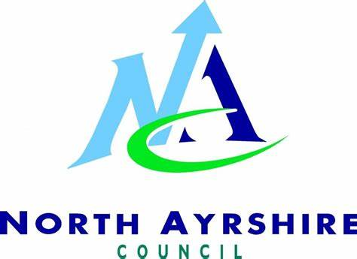

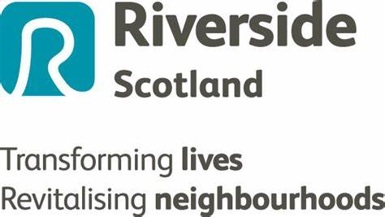

Table of Contents
1 | Introduction | 2
2 | Aims of the Policy | 2
3 | Legislative Framework | 3
4 | Prevention and Early Intervention | 4
5 | Community Planning Partners response to households experiencing domestic abuse. | 5
6 | Future Legislation | 6
7 | Monitoring the Policy | 6
Appendix 1 | North Ayrshire Violence Against Women Partners | 7

North Ayrshire Domestic Abuse Policy – All Tenures

Introduction

Partners across North Ayrshire recognise the impact domestic abuse has on victims and their families. As social landlords, we regard domestic abuse as unacceptable behaviour which will not be tolerated.
The North Ayrshire Domestic Abuse Policy – All Tenures (the Policy) is aligned to the Chartered Institute of Housing’s ‘Make a Stand campaign’. The Council and its partners have signed a pledge to demonstrate our commitment to this campaign to bring an end to domestic abuse in all its forms, ensuring our tenants and residents know their rights and understand how to access services.
The policy was developed by an inter-agency group comprising of North Ayrshire Council Housing Services, Cunninghame Housing Association, Irvine Housing Association, North Ayrshire Council’s Tenant Participation Team and North Ayrshire Women’s Aid and sets out our commitment to anyone in North Ayrshire who is experiencing or are concerned about another individual affected by domestic abuse. The policy is for all North Ayrshire residents irrespective of tenure or gender and complements the individual domestic abuse policies of the partner organisations.

2. Aims of the Policy

Domestic abuse in any form is unacceptable and will not be tolerated within our homes. As social landlords we are committed to protecting our tenants and residents, ensuring they are aware of the range of services available to them and how as a landlord we will assist.
Social housing providers and partner agencies will provide a proactive housing response to preventing and addressing domestic abuse by:

- Ensuring everyone feels safe and is aware of the range of services available to them should they be at risk of domestic abuse

- Being sensitive and supportive towards any household experiencing domestic abuse

- Working in partnership with other agencies to help victims/survivors of domestic abuse to access information, advice, and support in respect of their Housing Options and the choices available to them

- Holding the perpetrators of domestic abuse to account

- Promoting equality and diversity by minimising the risk of gender-based violence, whilst ensuring support is available to anyone who needs it

- Ensuring that the housing and wider response is appropriate to the needs of the individual and in line with best practice

3. Legislative Framework
The Domestic Abuse (Scotland) Act 2018 received Royal Assent on 9th March 2018. This legislation creates an offence with respect to abusive behaviour towards a partner or ex-partner.
In 2019, the Act introduced new Police Scotland enforcement powers in relation to psychological abuse and coercive control. All domestic abuse: whether psychological or physical, is now a criminal offence, allowing Police Scotland and the courts to prosecute offenders.
The Scottish Government “Equally Safe” Strategy sets out the framework for the prevention and eradication of violence against women and girls, detailing national outcomes which local authorities and their community planning partners must work towards in order to achieve this, as detailed below:
- We live our lives free from crime, disorder, and danger

- We have tackled the significant inequalities in Scottish society

- We have strong resilient and supportive communities where people take responsibility for their own actions and how they affect others

- Our children have the best start in life and are ready to succeed

- We have improved the life chances for children, young people, and families at risk

- Our public services are high quality, continually improving, efficient and responsive to people's needs

- We realise our full economic potential with more and better employment opportunities for our people

- We live longer healthier lives

The National Equally Safe Strategy and Implementation Plan (which has been incorporated into the Safer North Ayrshire Strategy) can be found here. Equally Safe: national strategy - gov.scot (www.gov.scot)

4. Prevention and early intervention
A key objective of the policy is prevention and early intervention. Our prevention focus has three key strands:
- The first is to ensure that employees across the Community Planning Partnership recognise that gender-based violence in all its forms is not acceptable.
- The second strand is focussed on awareness raising, ensuring that everyone knows that violence is unacceptable. We will ensure that everyone has access to a range of information, enabling them to challenge attitudes should they feel they need to.
- Finally, prevention will be targeted at both the perpetrators and victims of domestic abuse, ensuring that they recognise that violence in any form is unacceptable and that they know how and where to access services should they require them.
The Community Planning Partners are committed to working with a range of stakeholders to highlight the impact of domestic abuse and the role they must play in preventing it.
The prevention and early intervention strategy will focus on awareness raising, ensuring that everyone knows that violence in any form is not acceptable. We will actively promote gender equality and challenge attitudes of stereotyping and inequality by developing a media and messaging campaign which reaches every household in North Ayrshire.
We will ensure that our employees across the Community Planning Partnership can identify the risks and signs of domestic abuse and that they know who to approach should they have concerns about anyone.
We will adopt a proactive, victim centred approach that promotes and strengthens the rights of those experiencing domestic abuse to remain in the home, should they choose to do so. We will promote this approach as follows:
- We will deliver a rolling programme of training via the Violence Against Women Partnership domestic abuse training calendar across all Community Planning Partnership employees.

- The Violence Against Women Partnership will support primary and secondary schools to deliver age-appropriate, evidence-based interventions to raise the awareness and understanding of gender-based violence to children and teachers. As part of a whole school approach to tackling domestic abuse we will promote positive, healthy relationships and consent. This initiative is widely and successfully embedded throughout North Ayrshire schools.

- We will review our Tenants Handbook regularly to ensure the inclusion of a range of information about domestic abuse and service access.

- There will be ongoing promotion of gender equality awareness across a range of media platforms including information leaflets, newsletters and on the Council’s and partner agencies websites.

- We will clearly promote our commitment to eradicate domestic abuse by actively promoting details of the assistance that landlords will provide.

- The Community Planning Partnership will adopt an ‘eyes and ears’ approach which requires staff at all levels to feel supported and confident when raising concerns surrounding domestic abuse.

- The Community Planning Partners will adopt a no wrong door approach for those households experiencing domestic abuse.

- We will expand our Safe Contact Programme across local offices and businesses to ensure households experiencing domestic abuse can speak out and access services.

- The North Ayrshire Violence Against Women Partnership (VAWP) is responsible for the delivery of the national VAW strategic framework as detailed within the Safer North Ayrshire Strategy. On an annual basis the VAWP raises awareness through a range of activities delivered across North Ayrshire, culminating in our participation in the national 16 days of activism programme to end violence against women and girls.

5. Community Planning Partners response to households experiencing

domestic abuse.

This policy commits North Ayrshire social landlords to support people who are at risk of or experiencing domestic abuse. The needs of the victim will be at the centre of our approach to housing provision. We will:
- Maximise the flexibility of housing options available to those experiencing domestic abuse.

- Support those affected by domestic abuse to remain in their tenancy, if that is their choice; or if they prefer to move out of the tenancy, support them to do this.
- Assist victims of domestic abuse to access support from organisations such as Women’s Aid, the North Ayrshire Home Security Project and local counselling services.

- Support victims and survivors of domestic abuse to gain appropriate information and advice to ensure they understand their rights.
- Develop pathways for those who have experienced domestic abuse to improve their journey into a new home.

- Use relevant and appropriate legislation to support the rehousing choices of the victims of domestic abuse.

6. Future Legislation

The Domestic Abuse (Protection) (Scotland) Bill was introduced in Parliament on 2 October 2020. The Bill was passed by Parliament on 18 March 2021; however, regulations still require to be developed prior to implementation.
The Bill provides Police Scotland and courts with powers to make emergency notices and orders to protect people at risk of domestic abuse. This will include the power to remove a suspected perpetrator from a home they share with a person at risk of domestic abuse and prohibit them from contacting or approaching them in the future.
When the regulations for the Bill are finalised, this policy will be updated to reflect these new powers.

7. Monitoring the policy
The implementation of the policy will be monitored by the VAWP, with outcomes reported to the Safer North Ayrshire Partnership on an annual basis.
The policy will be reviewed annually by the VAWP.

Appendix 1

North Ayrshire Violence Against Women Partners
Agency
Council Cabinet Member for Green New Deal and Sustainability - Chair
VAWP Co-ordinator – Housing Services Community Safety
NA Child Protection
Barnardo’s
MAASH
Police Scotland DA Unit
Fire and Rescue
Police Scotland Liaison
NA Education
NA Community Planning Partnership
NA ASP Learning & Development
Break the Silence
Justice Services
NA Child Protection
NA Housing
NA Welfare Reform
ASSIST
Public Health
Women’s Aid
HSCP C&F
STAR Centre
NA Connected Communities
NA Alcohol & Drugs Partnership
Home Security Project Officer
Community Safety Services
Choose Life
Community Justice Ayrshire
Victim Support
Service Access, H&SCP
Education
NA Human Resources
Social Services

